1.
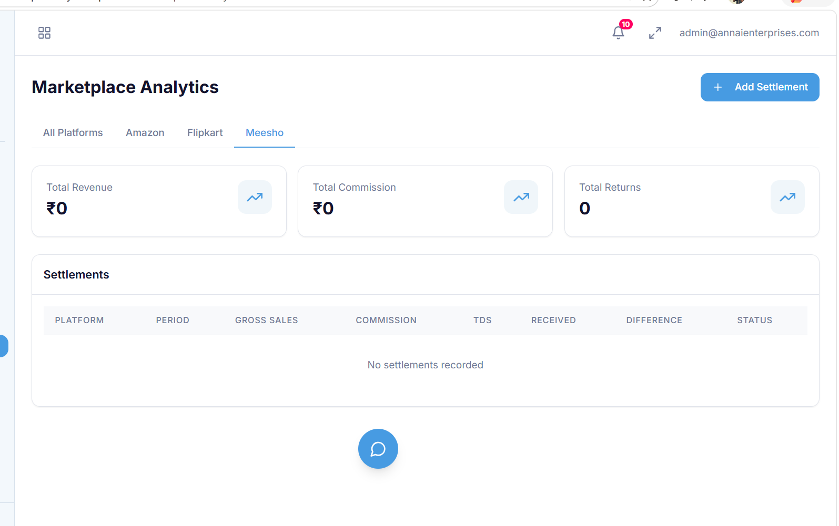
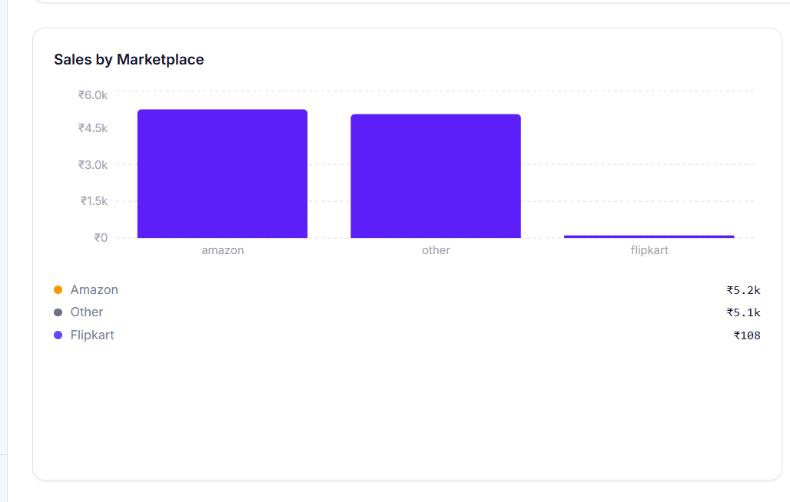
no settlements and the amazon payments are seen here , but seen in the dashboardis it not fetching from db?
2.
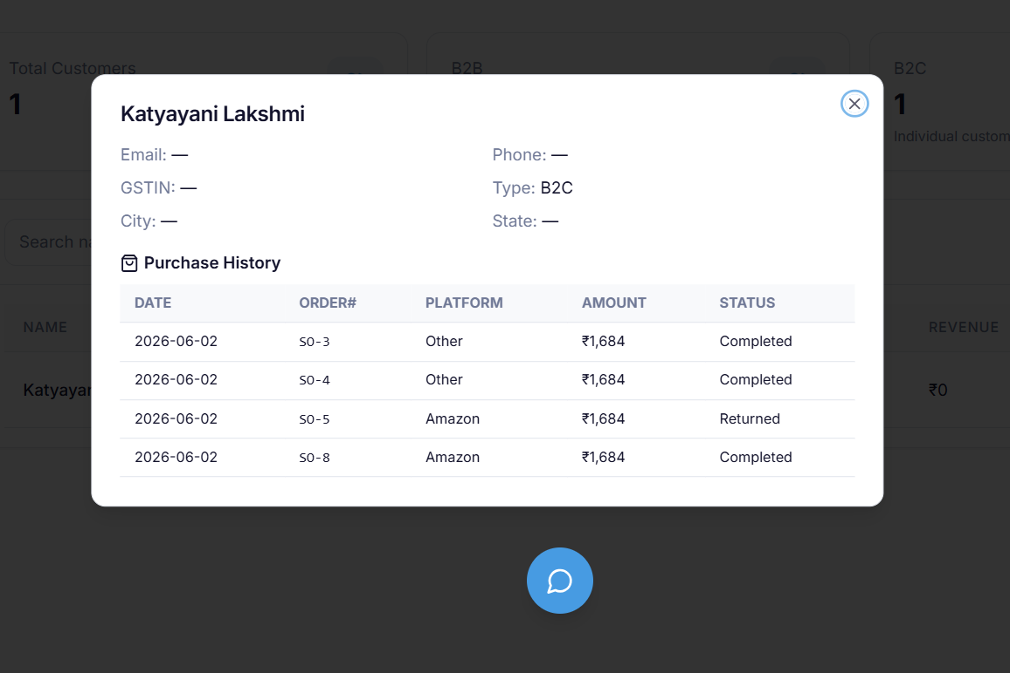
it is showing all the purchases and all but not getting the address and other details, is t not fetching or it is not at all there in the db?
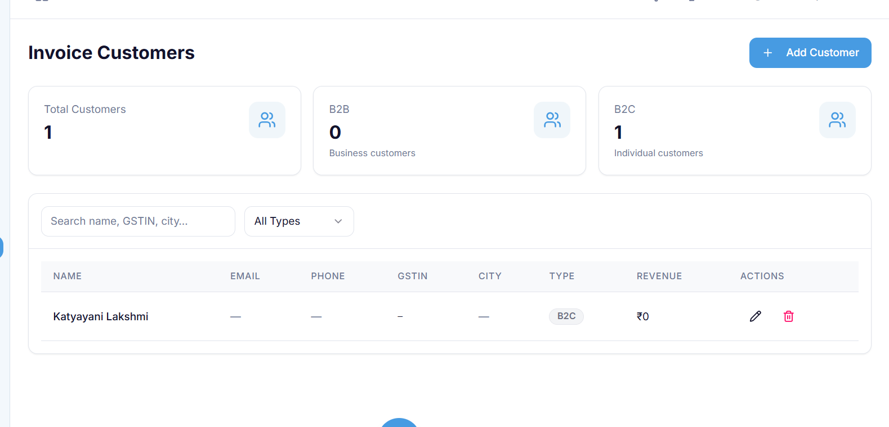
and it is showing revenue 0

3.
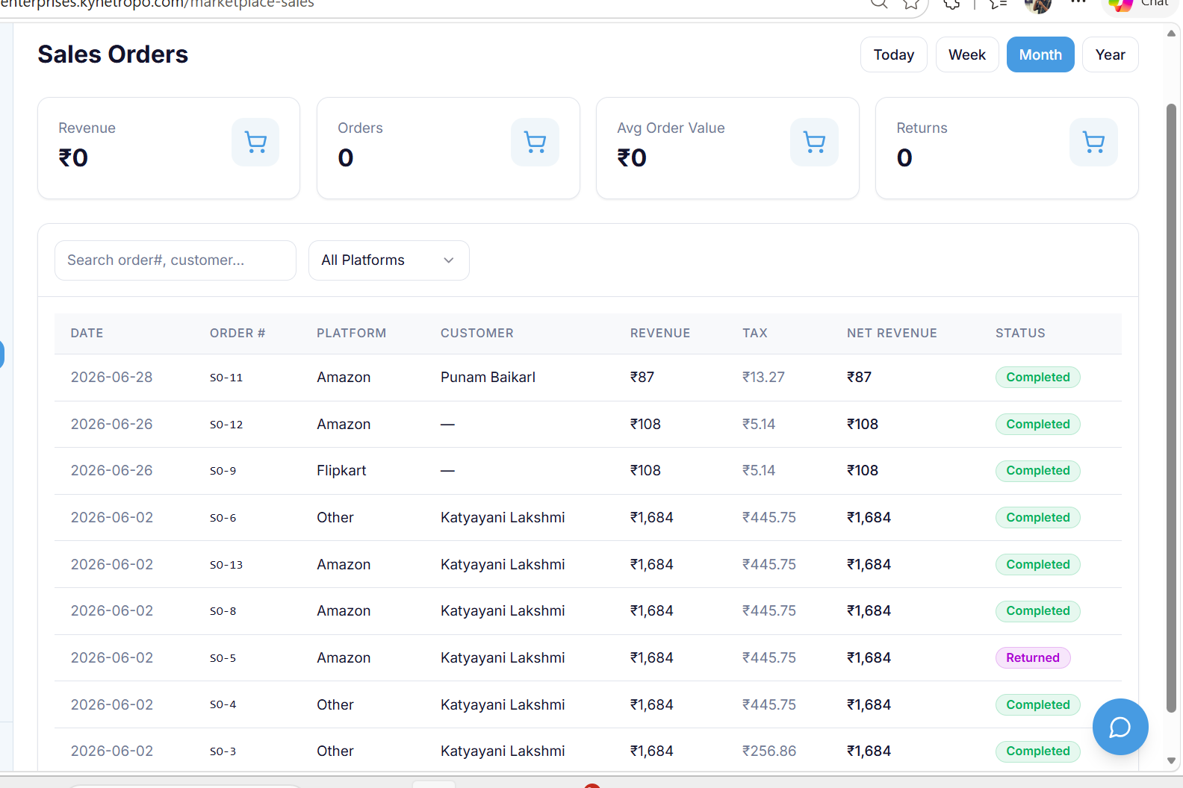
Revenue is showing 0 even though I have teh revenues-
4.
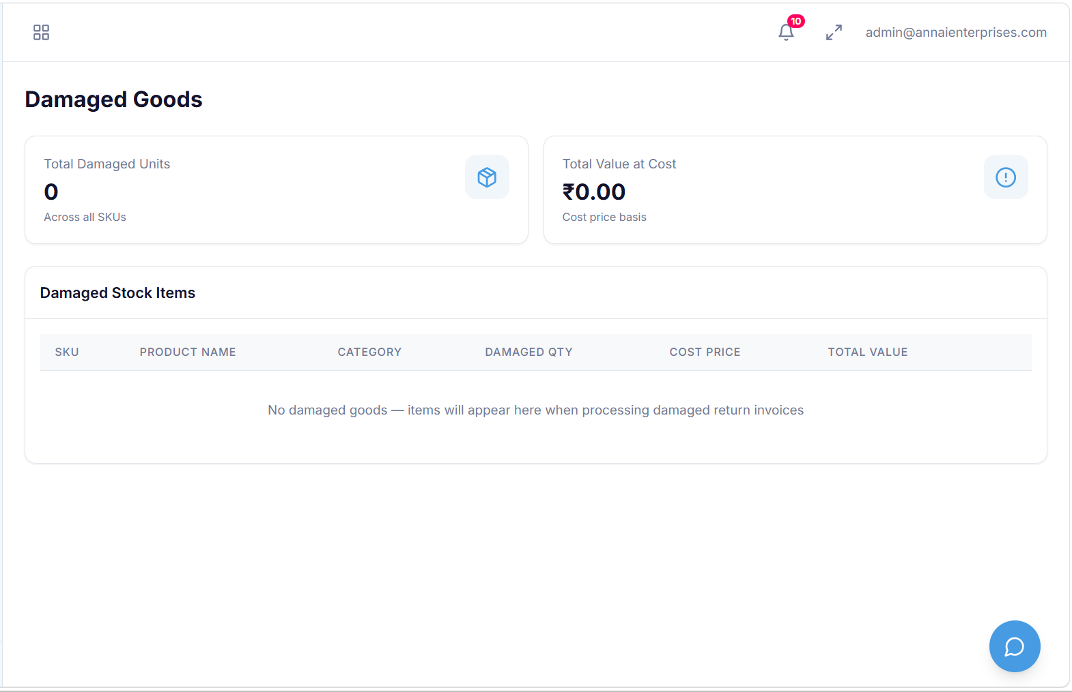damaged goods showing nothing even though i have uplaoded a invoice in damaged section and pop up came saying that it is moved to damaged goods

5.
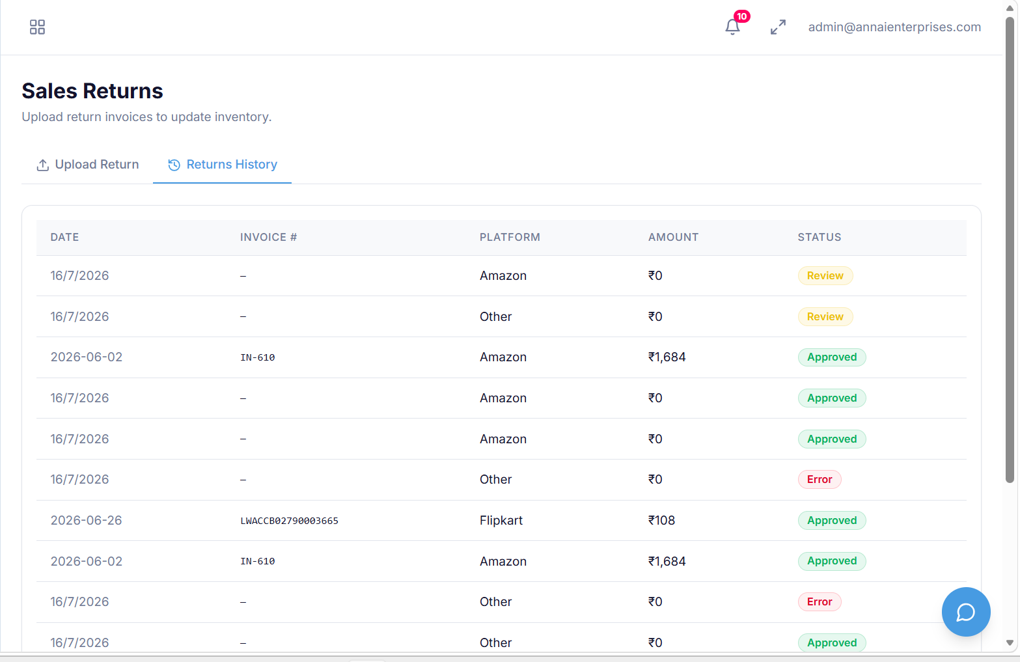
Here in sales returns page in the returns history , it is showing all the invoices here, it should show only the returns invoice and why is it waiting for review? It should be returned tahts it

6.
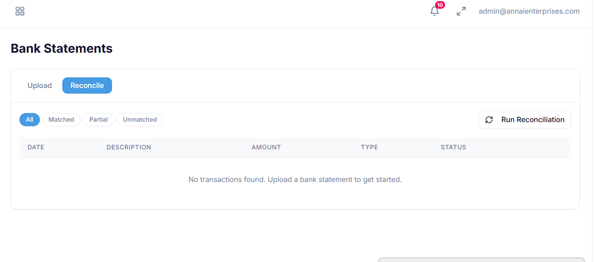
after i uplaod a bank statement, it is showing nothing here in this

